New Portal for “Online Shop RT Intimation Note”

Add detial or mobile no of containers /Stores or others with mobile no

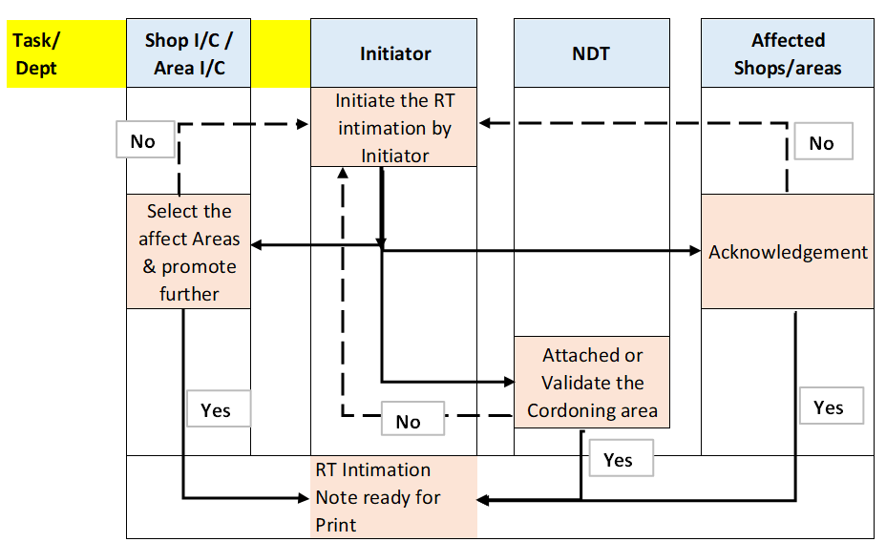
- Work flow

Following functionality required in admin role.
- Layout Directory: Tab required to add /delete /edit Layout of area
    - The following columns are required to update the layout
      - Area name
      - Date of update
      - Attachment (PDF,JPEG etc)
- Area-wise Shop In-charge Library:
    - Area wise (From MTR Table) shop I/C (From Directory of HE & Defence) to be maintain in library
- Contractor Library for Store/Container office
Below listed columns are required
  - Contractor name: - Text Field
  - Drop down selection: Store /Office
  - Area name : Text Field
  - Mobile no : Numerical filed & allow only 10digit

- Initiate the RT intimation Note

  - User will Initiate RT Intimation
  - Session should be easy and user-friendly
  - Accessible from mobile (internet base)

- Fields to be displayed (Only display fields)
  - Name of User
  - Department of User
  - His Extension Number
  - His Mobile Number
  - Date of request

- Fields to be included in the form are as follows:
  - Location : Drop Down from AMHEC-East / AMHEC-West
  - Shop/Area of RT: Drop down list from “MTR table” (Logistic) based on the selection of locations
  - Project : Drop Down /Auto fill - To be Fetched from IEMQS
    - Project Description: Shall be displayed- Auto fetch from IEMQS
    - Customer name: Shall be displayed- Auto fetch from IEMQS
  - Seam no - Dropdown /Auto filled from selected projects
  - Spot No : (Text Field ) Non Mandatory
  - Weld Thickness in mm : Number Field
  - Clearance time From : Selection from Calander date & time
  - Clearance time to : Selection from Calander date & time
  - Add button : Required to add multiple From & to Time for same date as well as other date
  - Durations : Calculate Hrs on each row based on selection of Date & Time
  - Affected Shops : Multiple selection options from “MTR table” based on locations
  - Contractor : Selection of name of contractor /area from library
  - Dept : Select name of the department (Either K , I or m any one is mandatory for selections)
  - Persons for Affected shops : Selection from Employee library for Affected shops (k) and Dept(k) , Multiple selection of persons required
** Person Directory required for HED & Defense both
**Persons should be selected against multiple selection of each shop

  - Reason for shop RT /Remark : Text Field

  - Check Box /selectins for following
    - Following requirement shall be full filled by shop
      - Adequate Lightning : YES/NO/NA
      - Scaffolding arrangement : Yes/NO/NA
      - Operator for rotating jobs (Job on Tank Rotators) : Yes/No/NA
  - Entire Workflow can be checked any times for pending actions by every one.

Note -
      - We ensure that the shop RT procedure (HED-HZW-NDT-P-051-R3) dtd.14/08/2013, will be followed by shop supervisor Mr.___(Text Field)___________________ will co-ordinate with NDT personal for safety purpose.

      - REQUEST WILL BE AVAILABLE THRO’ SYSTEM 2 HOURS BEFORE SHOP RT.

  - Layout: Select the available layout from “Layout Directory” or from old Released RT Intimation (Search options required for Shop /Project)
    - Provision required to mark the following in layout & save
      - Cordoning Area
      - Showing Job locations (Square/Round other shapes)
      - Showing RT shield /Cement block
      - Adding text at required location with arrow
    - Other attachments : Provisions to attached other attachments (Non Mandatory)

  - After submitting request mail to be triggered to Area Incharge of RT locations, NDT persons & Affected shops. Users shall be able to access directly from mail (Hyperlink shall be available on mail to open the request page)

- Validate Cordoning area – NDT Persons
  - NDT persons able to view the read-only detail of all the fields except shop layout & Name of affected shops
  - NDT persons can modify the Cordoning areas in layout as well as adding or deleting the affected shops

  - He will have 2 options, one to acknowledge with comment or return with comments

  - Comments shall be Display in RT intimations print

  - If NDT persons add the additional name of Shop & persons, mail to be triggered to shop persons CC to initiator after submitting request by NDT

  - Mail to be triggered to Initiator after acknowledging the request from NDT

- Update Intimation after Acknowledgement – Shop I/C

  - Shop I/C is able edit all fields other than SHOP ,Project & Seam nos
  - Initiator can change/delete timing as well as affected shop & It’s persons
  - If new shop/area added by Shop I/C , one mail to be triggered to selected persons cc to initiators
  - Shop I/C can return or acknowledge the intimations

- Acknowledge by Affected shops
  - Affected shop persons can view the details & accept the RT intimations or decline the RT intimation with comments. Provisions required to add the comment & display in RT intimations print

- Approved RT intimations
  - Once all the affected persons , NDT persons & Shop I/C accepted the RT intimations mail to be generated to all concerned persons selected to RT intimation including the Initiators for print.
  - SMS to be generated to contractor persons with area name and timing of RT
  - After approved /acceptation print of RT intimation can be taken by anyone along with layout (Print /view option should along with layout only)
  - Portal shall store the history of intimation
  - Two tabs required in portal i.e Live RT intimations note and completed Intimations (Live is defining based on date & time selections)

- RT Planning
  - Post-Approval Data Entry (RT Team)
Once the RT request is acknowledged and approved by all concerned stakeholders, the system shall enable the RT Team to capture the following details:
- RT Vendor Name
- RT Execution Duration
  - Start Date (From)
  - End Date (To)
- Radiographer Details
  - Name
  - Mobile Number
- Camera Details
  - Automated Notification – RT Planning
The system shall trigger an automated email notification to:
  - Request initiators
  - All affected stakeholders
- The notification shall include RT planning details entered by the RT Team.

  - Post-Execution Data Entry (Radiographer)
Once RT activity is completed, the system shall allow the Radiographer to update the following:
- RT Status (Mandatory field)
  - Completed
  - Partially Completed
  - Not Completed
- Remarks / Reasons
  - Mandatory if status is Partially Completed or Not Completed
  - Provision to upload supporting attachments
- Number of Spots Radiographed

  - Final Status Communication
- After all required updates are completed, the system shall:
  - Consolidate RT execution data
  - Trigger an automated summary email
- The email shall include:
  - RT status overview
  - Key remarks (if any)
  - Execution details

- Copy Functionality
  - Initiator can copy the entire Intimation (Search options required shop/project/seams/date for selection from list)
  - If initiator is not changing the project no, seam no, shop/area and layout , Request will directly go to shop I/C. Stage of NDT persons will by-passed.
  - If any changes in Project,Seam,Shop and layout , request to flow as new request
- Reports
  - Report shall be available for no of intimations /shop wise /project wise/area wise
  - Shop wise /Person wise tame taken to approve /Acknowledge intimations
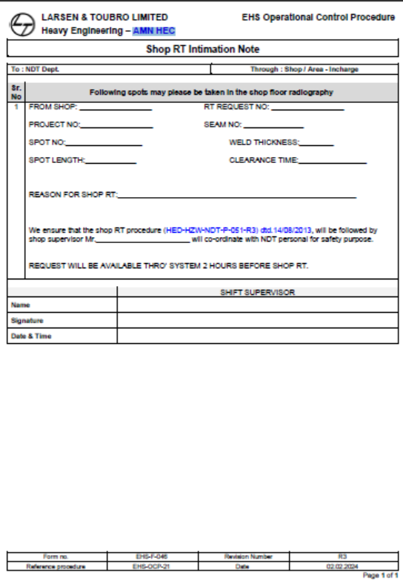
SHOP RT intimation print format

